Purchase Quantity-
The next important decision in inventory management is related with the purchasing quantity i.e., how much to purchase? For this the inventory control techniques are used by the purchasing manager.
Inventory control is the systematic control and regulation of purchase, storage and usage of materials in such a way as to maintain an even flow of production and at the same time avoiding excessive investment in materials. Efficient material control reduces losses and wastages of materials that otherwise pass unnoticed.
Inventory control is the core of materials management. The need and importance of material varies in direct proportion to the idle time cost of men and machinery and the urgency of requirements. If men and machinery in the factory could wait and so could customers, materials would not lie in wants for then and no inventories, need be carried. But it is highly uneconomical to keep men and machines waiting and the requirements of modern life are so urgent that they cannot wait for materials to arrive after the need for them has arisen. Hence firms must carry materials.
Because materials constitute a significant part of the total production cost of a product and since this cost is controllable to some extent, proper planning and controlling of inventories are of great importance. Material control is a planned method of determining what to indent, so that purchasing and storing cost are minimum without affecting production or sales. Without proper control, materials have a tendency to grow beyond economic limits. Funds are tied up unnecessarily in surplus stores and stocks, productive operations are stalled, and finances of the plant are severely strained. Lack of control over material also leads to excessive consumption and wastage as operatives are liable to become careless with irrational supply of materials.

Economic order quantity-
The basic problems of material control are two viz., what quantity of an item should be ordered at a time and when should an order be placed. While deciding economic ordering quantity, the efforts are directed to ascertain the ideal order size. While deciding the ideal order size, factors such as material carrying charges and the ordering cost associated with the placement of purchase orders are to be considered; the total of both has to be minimised. The material carrying charges include interest on the capital invested in the stores of materials, rent for the storage space, salaries and wages of the store-keeping department, any loss due to pilferage and deterioration, stores insurance charges, stationery, etc. used by the stores, taxes on inventories, etc. Ordering costs may include rent for the space used by the purchasing department, the salaries and wages of officers and staff in the purchasing department, the depreciation on the equipment and furniture used by the department, postage, telegraph charges and telephone bills, the stationery and other consumables required by the purchasing department, any travelling expenditure incurred, and the costs of inspection etc., on receipt of material.
The optimum ordering quantity, i.e., the quantity for which the cost of holding plus the cost of purchasing is the minimum is known as Economic ordering Quantity and is calculated by the following formula:

Economic Ordering Quantity
Annual consumption (units) during the year Cost of placing an order
Annual cost of storage of one unit.
U =
P =
S =
E.O.Q.= 2U × P
S
Where,
E.O.Q. =

While deciding the question as to what should be the economic ordering quantity one has to ensure that the cost incurred should be minimum. An ideal order size, therefore, is at the quantity where the cost is minimum i.e., cost of holding the stock and ordering cost intersect each other. This is graphically shown hereunder:
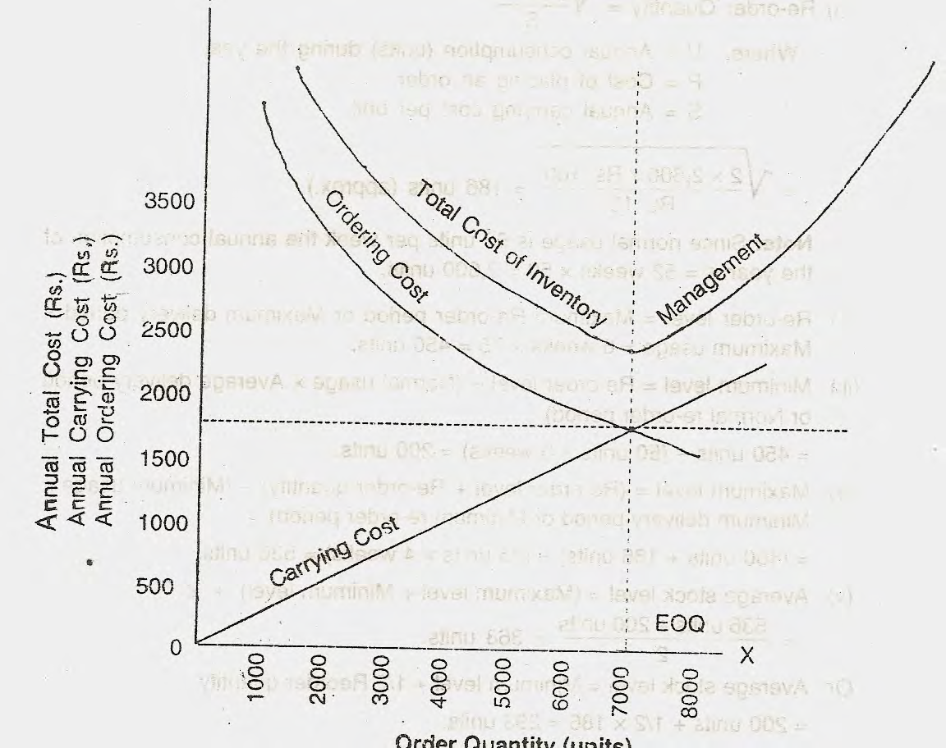order units

Maximum Level:
This represents the minimum quantity above which stocks should not be held at any time.
It is normally a matter of policy. The various factors that should be taken into consideration are:
- Capital Outlay: Investment to be made in stores, raw materials and other bulk items is an important consideration.
- Available storage space for material.
- Storage and insurance cost of material.
- If certain goods are subject to obsolescence, the spare parts and components etc. of such products stocked should be limited.
- Consumption of material periodically i.e. monthly, annually.
- Lead time for delivery of material.
- Certain goods are seasonal in nature and can be purchased only during specific period. Hence maximum level will be fixed for each season.
- Price advantage arising out of bulk purchases should be availed.
- The Economic Order Quantity also influences the maximum level.
Maximum stock level = Re-order level + Re-ordering quantity – (Minimum consumption x Minimum reorder period)

Minimum Level:
This represents the minimum quantity of stock that should be held at all times.
The minimum level is also a matter of policy and is based on :
- Consumption of material periodically i.e. monthly, annually.
- Lead time for delivery of material.
- The production requirement.
- The minimum quantity that could be advantageously purchased.
If an item is made to order then no minimum level is necessary
Minimum level = Re-order level - (Normal consumption x Normal re-order period).

Ordering Level:
It is the level at which indents should be placed for replenishing stocks. The annual consumption of an item and the time lag between ordering and receiving can be collected from past records. Based on these facts and policies, the ordering level and ordering quantity can be calculated, as follows:
Ordering level = Minimum level + Consumption during time lag period
OR
Maximum consumption x Maximum re-order period.
OR
Maximum consumption x Lead time + Safety Stock

The ordering level should be fixed so that when an indent is placed at the ordering level, the stock reaches the minimum level when the replenishment is received. The ordering level is calculated from the following factors:
- The expected usage
- The minimum level
- The lead time.

The order point is calculated keeping in mind the worst conditions so that minimum stock is always maintained.

Danger Level:
Normal issues of stock are usually stopped at this level and made only under specific instructions.
Material consumption varies from day to day, week to week and hence accurate forecasting is not possible. A safety or reserve stock is kept to avoid stock-out. The desirable safety stock level is that amount which minimises stock-out costs and also the carrying costs.
This level is a level of stock between the minimum level and nil stock. It is calculated for those items which can be utilised for multiple orders or products. The store-keeper usually does not issue once the danger level is reached. Usually priority is given to some order/product for the use of these items. This level is fixed up specially for control of production so that priority items can be produced.
This level is sometimes fixed above the minimum level. In this case, this level is preventive. If the level is below the minimum level, this level is corrective.
The safety stock level can be computed as follows:
Safety stock level =Ordering level – (Average rate of consumption X
Re-order period)
OR
(Maximum rate of consumption - Average rate of consumption) X Lead time

